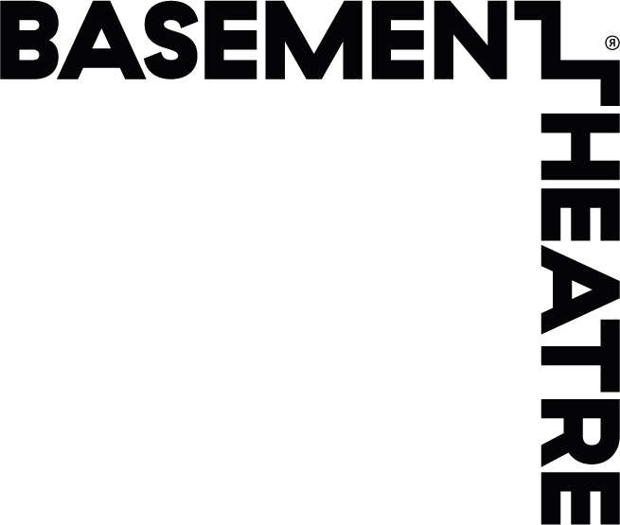

APPLICATION FORM FOR THE BASEMENT AND AUCKLAND ARTS FESTIVAL WORKSHOP WITH DESIREE BURCH.

Auckland Arts Festival and The Basement Theatre present a 2 hour masterclass with writer, comedian and actress Desiree Burch whose solo theatre show TAR BABY is playing at Auckland Arts Festival 2016.
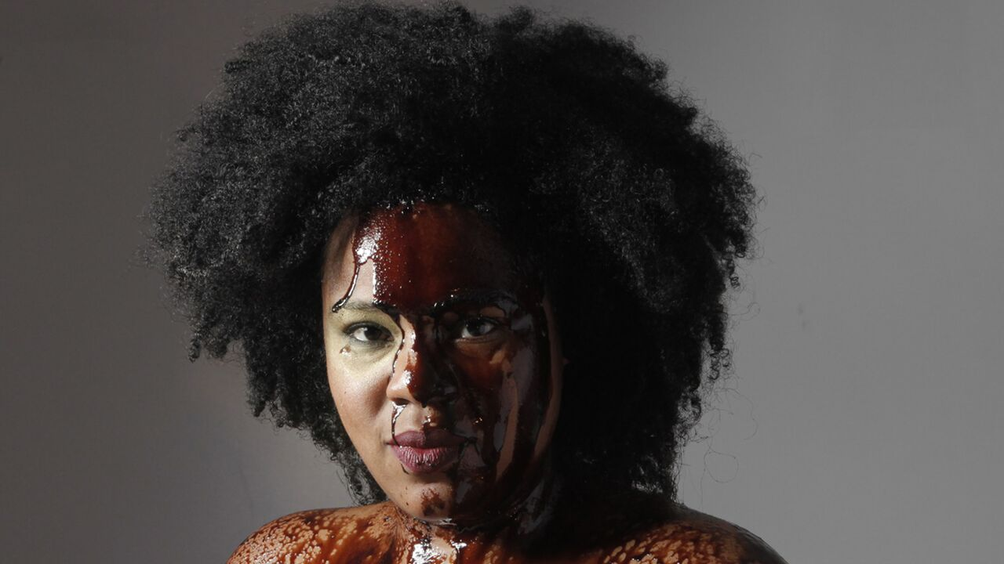
THE WORKSHOP: RAISING THE STAKES
WHERE: The Basement Theatre, Lower Greys Ave, Auckland City
WHEN: Friday 4 March, 2 - 4pm
PRICE: $50 - includes 1x ticket to opening night of Tar Baby – Thursday 3 March, 9:30pm.
Please note there is a maximum of 10 participants for this workshop.
APPLICATION DUE: Friday 19 February at 5pm
2015 Funny Women Award-winning Fringe First-winning writer/performer Desiree Burch creates honest, raw performances that viscerally charge audiences to take on intellectual ideas. In this 2-hour workshop, the "Tar Baby" creator will guide participating artists in generating gutsy, original work that engages and activates audiences. Using games, images, tasks and objects, artists will organically develop structures that transform personal texts into dynamic encounters with playfulness and risk.
The workshop is suitable for emerging and newly established artists with an interest in solo work and/or writing.
Please note for the workshop, participants should prepare three assignments:
- Participants should write a one paragraph publicity/marketing “blurb” in which they advertise the piece they would like to create. The aim is to consider how this work would be meaningful not only to them, but to a wider audience—with an awareness of who that audience might be.
- In a notebook, artists should write down, in one page or less, a recent (past two weeks) dream that they have had. Then artists should condense that dream into a three-line story that has a beginning, middle and end. Please bring this notebook, including both versions of the dream, to use during the workshop.
- Participants should also bring with them an interesting, meaningful, silly or simple object. Please make sure it is shareable with others.
ABOUT DESIREE:
Desiree Burch is a comedian, actor, writer and storyteller. She was raised in L.A., developed artistically in NY and currently resides in London. Her brash and energetic comedy style has been seen on NBC and E4 and made her the winner of the 2015 Funny Women Stage Award for stand-up. As a writer and performer, she makes raw and gutsy work. Her critically-acclaimed solo show 52 Man Pickup has toured internationally and her solo piece Tar Baby won a 2015 Fringe First for new writing at the Edinburgh International Festival Fringe.
Desiree has 15 years’ experience as a performing artist, storyteller and educator. She worked nationally as a master teaching artist and facilitator with the American Place Theatre, and has lead performance-writing workshops for Perry Mansfield, The New York Neo-Futurists, Queens Theatre in the Park, and the New Orleans Fringe, as well as at several universities.

Tar Baby
CREATED BY DESIREE BURCH
Tar Baby is a solo show that tackles the story of race in America. Co-written with playwright Dan Kitrosser and performed by Desiree, this solo and interactive performance piece seeks to speak to the growing majority of minority experiences in America and beyond. In 2015, Tar Baby received a Fringe First Award for new writing at the Edinburgh Fringe, and the Scotsman called it “One of the most breathtaking monologues you’ll see this entire month”. It was also shortlisted for the Amnesty International Freedom of Expression award. Tar Baby weaves personal and social narratives in this hilarious, provocative and deeply moving performance that is “smart, original, refreshing and maybe even necessary.” (–New Yorker)

Enquiries and applications to: gabrielle@basementtheatre.co.nz
Please remember we have limited slots available to offer practitioners and unfortunately will not be able to accept all those that apply.

NAME:
PHONE:

EMAIL:

PLEASE PROVIDE A BIO OUTLINING RELEVANT EXPERIENCE please keep this to a maximum of 300 words:

WHY IS PARTICIPATING IN THIS WORKSHOP IMPORTANT TO YOU?

WHAT WOULD YOU BE INTERESTED IN GETTING OUT OF THIS WORKSHOP?

WHAT TYPE OF WORK ARE YOU INTERESTED IN CREATING?

WHAT IS YOUR FAVOURITE PIECE OF THEATRE YOU HAVE EVER SEEN AND WHY?

ARE YOU CURRENTLY CREATING YOUR OWN WORK? If yes, please provide more information.

Please email your submission to gabrielle@basementtheatre.co.nz

