Call for Volunteers:
Family Day /Whānau Whānui – Sunday 13 March 2016
Volunteers required from 9.30am- 4pm

Auckland Arts Festival’s Family Day is a fun, free day of activities and performances for everyone in the New Zealand Herald Festival Garden in Aotea Square.
The Festival Garden is the hub of the Festival, so we need a crew of volunteers to help artists run activities and to engage with the public, to ensure the day is well run and successful.

As a volunteer you will be asked to co-manage an activity or space on a rotational basis and will be fed and watered as it is a long day.

To be a volunteer for Family Day you must be reliable, have initiative and enjoy engaging with people of all ages, and have a working cell phone.

All volunteers will receive a FREE Auckland Arts Festival t-shirt and a letter of reference stating how awesome you were.

If you’re keen, please contact
Nicole Arrow | Programme Assistant – Education & Community
nicole.arrow@aaf.co.nz

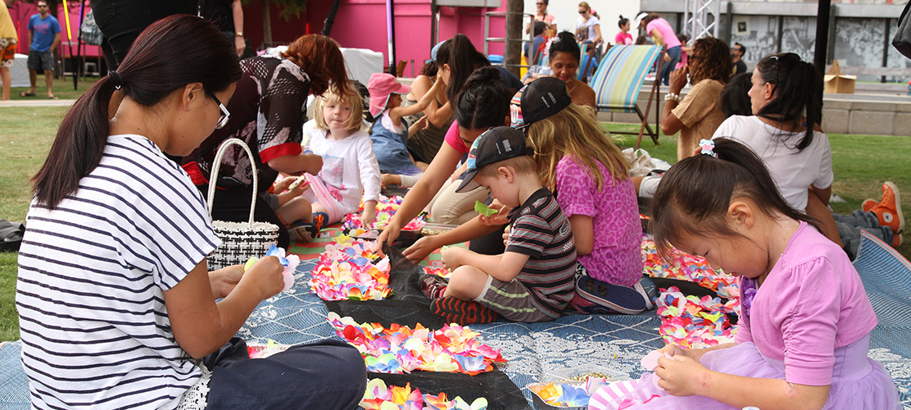

http://www.aucklandfestival.co.nz/events/family-day-wh-nau-wh-nui-at-the-new-zealand-herald-festival-garden/

