Waves
By Alice Mary Cooper
Creating theatre work for all ages

THE PRODUCTION
In association with Catherine Wheels and Imaginate
Created by Alice Mary Cooper

A performance for ages eight and up.

Waves is a solo theatre work written and performed by Alice Mary Cooper telling the story of the unofficial history of the invention of the Butterfly stroke. Combining new writing, highly expressive storytelling, delicate movement and humour, Waves is the amazing tale of Elizabeth Moncello and how, growing up on Gabo Island (Australia) in the 1930’s, she employed sea creatures to teach her how to swim. With the help of fish, penguins and amphibian friends, Liz, the daughter of immigrants, developed ‘the Dolphin,’ known to the world as the Butterfly.
Waves is an intimate, small scale, direct piece of theatre. The set is very simple and includes just a table, a chair and a couple of small props. In it the performer Alice speaks directly to the audience engaging them in the story with highly expressive storytelling, delicate movement and humour.

THE COMPANY
Performer (Alice) Alice Mary Cooper
Stage Manager Laura Hawkins
Creator Alice Mary Cooper
Director Gill Robertson
Designer Lisa Sangster & Alice Mary Cooper
Composer Danny Krass
Dramaturgical support Naomi O’Kelly
Lighting Designer Alice Mary Cooper
Artistic Director Gill Robertson
Producer Louise Gilmour Wills

Waves Creators Notes

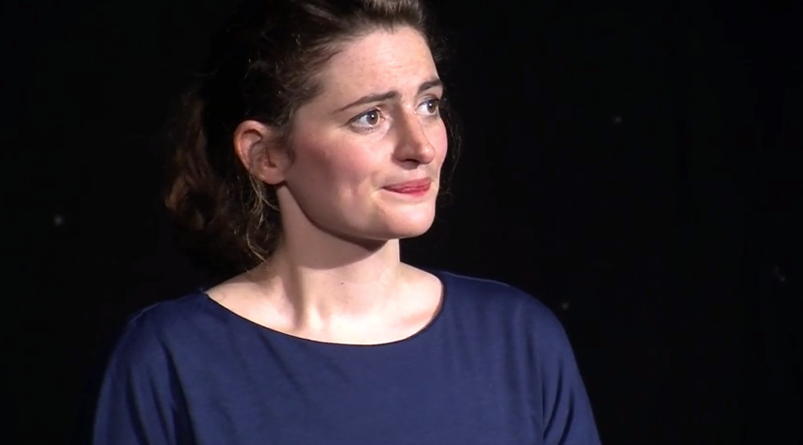
Waves started as a short story I wrote for a French magazine Jean Marie. The theme for the edition was ‘Islands’ and so I began researching, finally choosing Gabo Island as my setting for a tale. The play grew from there. While the character is fictional, the story is influenced by my own love of swimming and perhaps moreover, by doing laps in a pool named ‘The Fanny Durack’ in my hometown of Sydney. I was interested in creating a work that paid homage to pioneering female swimmers of the early 1900’s, of which Fanny was one. I also felt that too many women ‘of a certain age’ particularly from that era disappeared without a trace. Even though Elizabeth may not have existed I am certain incredible people like her did, but were not recorded by history’s grand narrative. There is always more than one history, particularly when it comes to inventions.
Image: Jonathan Charles

THE CREATIVE TEAM

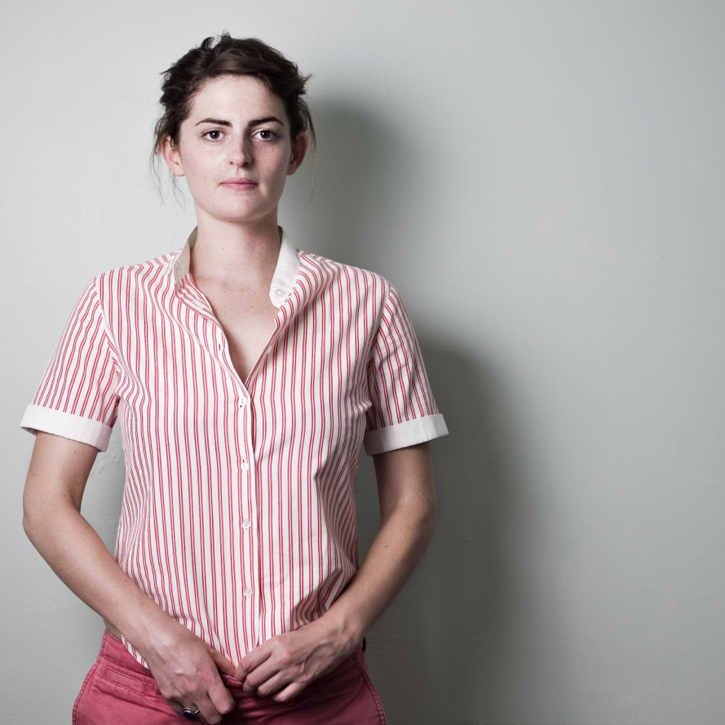
Alice Mary Cooper – creator (and performer)
Alice Mary Cooper is a performer and theatre-maker from Sydney, Australia. She lives in Edinburgh where she is an Associate Artist with Imaginate, and is a FST Assistant Director Bursary Recipient with Catherine Wheels Theatre Company (2015-16).

Following a Bachelor of Creative Arts Degree (Melbourne University), Alice trained at L’Ecole Philippe Gaulier (Paris), was Resident Artist at Shopfront Contemporary Arts (Sydney), ensemble member at PACT Centre for Emerging Artists and was part of Fresh Ink & the National Studio, Australian Theatre for Young People’s Playwriting program.

Alice devises and performs solo performance works with a strong character and physical focus. To date she has made two very different pieces, Waves and When Alice (Cooper) met (Prince) Harry. Alice is currently collaborating on a new site-specific work for the Royal Shakespeare Company and is creating two new solo works, Blue Cow and The Box; a commission from the Harlow Playhouse, England (premiere autumn 2015).

Gill Robertson – Director

Gill Robertson is the founder and artistic director of Catherine Wheels Theatre Company. She has worked as a director, actor and drama mentor throughout Scotland. Her credits as a director include: White, Pobby and Dingan (winner Total Theatre Award), Kes, Caged, The Ballad of Pondlife McGurk, Kappa, Martha, Lifeboat, Cyrano, A Town Called Elsewhere and Hansel & Gretel (Catherine Wheels); The Purple Potting Shed (Topiary Dance); The Curious Scrapbook of Josephine Bean, Cinderella and Spend a Penny (Shona Reppe Puppets); Chasing Angels (Complete Productions); Giant Steps and Bill’s New Frock (Visible Fictions) and The Wizard of Oz (Lyceum Theatre). As a performer: Martha, Red and Frankenstein, The Lion of Kabul and most recently The Book of Beasts (Catherine Wheels); Cinderella and A Midsummer’s Night Dream (Brunton Theatre); and The Snow Baby (Catherine Wheels/macrobert co-production). She also directed Home: East Lothian for National Theatre of Scotland, which won best show for children & young people at the 2006 Critics Awards for Theatre in Scotland (CATS) awards.

Danny Krass – Composer
Danny has been working as a composer and sound designer since 2001. He began working in his native Sydney through his association with Australian Theatre for Young People.
Theatrical credits include: Who Cares (Royal Court); The Artist Man and the Mother Woman. Quiz Show, Spoiling, The Devil Masters (Traverse Theatre); Smokies (Solar Bear); Up To Speed (Imaginate/Ros Sydney); The Adventures of Robin Hood (Visible Fictions/Kennedy Centre); The Voice Thief, Stuck, The Ballad of Pondlife McGurk, White, Kes (Catherine Wheels); My House, A Small Story (Starcatchers); Peter Pan (Sherman Cymru); Skewered Snails, He-La (Iron Oxide); Mikey and Addie, Littlest Christmas Tree, Rudolf, Mr Snow, The Little Boy that Santa Claus Forgot (Macrobert); The Infamous Brothers Davenport (Vox Motus/Royal Lyceum Theatre, Edinburgh); One Thousand Paper Cranes (Lu Kemp); The Curious Scrapbook of Josephine Bean, Huff (Shona Reppe Puppets) and The Day I Swapped My Dad for Two Goldfish, The Tin Forest (NTS). Couldn’t Care Less (Plutôt la Vie/Strange Theatre) Sanitise (Melanie Jordan & Caitlin Skinner).

Lisa Sangster- Co-designer
Lisa trained at the Royal Welsh College of Music and Drama. Her design credits include Waves, Alice Cooper, Blood Wedding, Cars and Boys, The Snow Queen, Whisky Galore, Baby Baby and Talking Heads, Dundee Rep; O is for Hoolet, Arches, How to Choose, Trigger; News Just In, The Incredible Adventures of See Thru Sam, Double Nugget, Smalltown, Little Johnny’s Big Gay Wedding, Promises, Promises, Little Johnny’s Big Gay Musical, Random Accomplice; Rantin, Jump, Transform: Dumfries, National Theatre Scotland; Misper, Scottish Opera; Educating Ronnie, Utter/Macrobert; BBC Comedy Showcase, BBC Scotland; My Romantic History, Borderline; Carthage Must be Destroyed, Ustinov Studio; The Pearlfisher, strangers, babies, Broken, Distracted, White Point; Traverse.
Naomi O’ Kelly- Dramaturgical support
Naomi O Kelly is a theatre maker, storyteller and participatory artist. As a director, Naomi has made playful, physical theatre since 2008, in Ireland, London and Scotland. Her work includes The Pied Piper, which won awards for Best Director (Mid-West Arts, Culture and Media Awards, Ireland), Best Production (Unfringed Festival, Ireland) and a Judges' Award for best ensemble (Unfringed Festival). She has an MFA in Theatre Directing from Birkbeck, University of London, and was Resident Assistant Director at the Lyric Hammersmith Theatre (London) for 2010-11.
Naomi has also worked extensively as a storyteller and participatory artist.
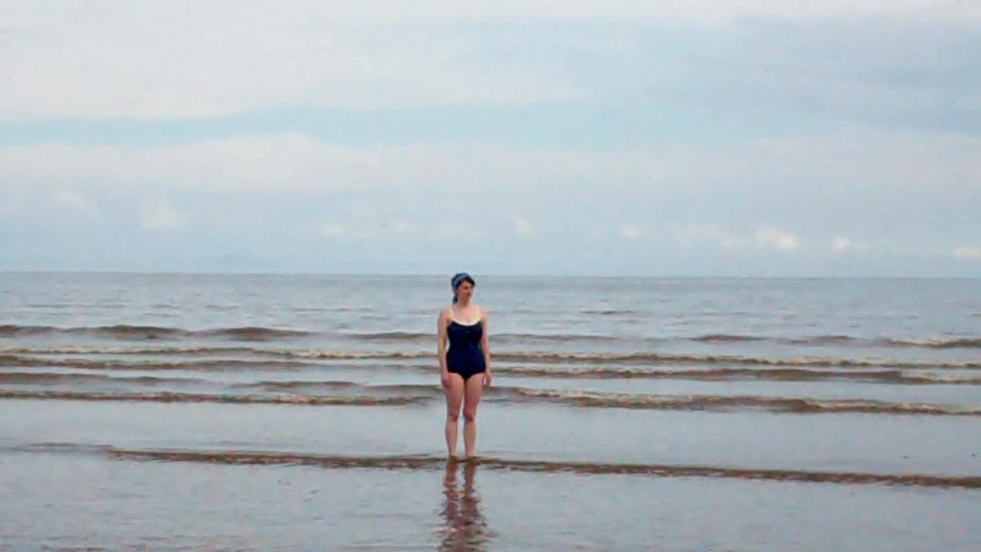
Image: Steven Largouet
WHAT THE PRESS HAVE SAID – THE COMPANY AND CREATIVE TEAM
‘Cooper is a performer and storyteller dedicated to instilling a sense of wonder in her audience.’
Broadway Baby

‘Creator Alice Mary Cooper has an understated but highly distinctive performance style, merging elements of storytelling, acting and physical theatre. ‘
Fringe Guru Richard Stamp

‘Alice Cooper is mobile and articulate, expressive and immaculately nuanced as she engages the observer in bending the shape of our momentarily shared reality.’
Rip it Up (Adelaide)

Gill Robertson (Catherine Wheels Theatre Company Artistic Director)
An innovator in children's theatre (The Guardian)
World class work for children and young people (The Herald)
Robertson is one of the most internationally successful theatre practitioners in Scotland (Scotland on Sunday)

Danny Krass
Danny Krass' original compositions and sound design are a wonderful support both to the presentation of the concepts and the safe, playful atmosphere
My House, nytheatre.com

WHAT THE PRESS HAVE SAID – THE SHOW
All In Edinburgh Theatre
‘..fifty glorious minutes…imperceptibly crafted, cleverly told tale with its feel-good twists.’
Thom Dibdin

The West Australian
‘Cooper gives a wonderful performance as herself and Elizabeth. She has the strong, streamlined body of a swimmer and the expressive face and voice of a born storyteller.’
David Zambetti
Sydney Arts Guide
‘...the standing ovation at the end was our inadequate thanks for the smiles on every face as we left the theatre’.
Allan Chapple

Broadway Baby
‘an exciting glimpse of something truly beautiful…’

The Scotsman
‘Cooper tells her story beautifully’
David Pollock

The Stage
‘Waves demonstrates she (Alice Cooper) is just as good at writing as she is at charming an audience.’

The Herald
‘Cooper's mischievous, affectionate story-telling is a joy in itself, but the sincerity she brings to honouring Moncello makes her performance an inspiring gift to her 8+ audiences.’
Mary Brennan
Fringe Bunny, Perth
‘The story is told brilliantly by Alice Mary Cooper. Great show for all ages.’

Fringe Review
Highly Recommended Show
‘I strongly recommend this production for its warmth, confidence and accessibility’

