TE PŌ

When you fall in love - death is the last thing you think of. The danger in falling in love is that one day it’s going to end. Then you are left loving something that is not physical, like reaching for a glass that's no longer there. That's when your life turns from fact to fiction, at least the differences between the two become irrelevant. How precariously our lives flicker against this approaching dark. Te Pō is about grief, Bruce Mason, object based philosophy, and how truth and fiction are really the same. Three very different characters, Reverend Athol Sedgwick, Detective Inspector Brett and Werihe are looking for Bruce Mason who has gone missing. Their investigation into his disappearance seems to reveal more about themselves than him, and when Bruce is finally found on Te Parenga Beach a terrible truth about their own lives is revealed.
The plays main themes are love and death - two opposites. This concept of opposites is used throughout the piece. It is a play about grief and yet it presents itself as a farce. Our three characters are full of these opposites. Detective Inspector Brett is a man who is constantly searching for the truth but cannot see the truth about himself. Reverent Sedgwick is a man of belief who doesn't know what to believe. Werihe is blind and he sees more than anyone else.
The set emphasizes these opposites, the furniture moves from one side of the stage to the other, the door moves as well, so at one point everything in the room ends up on opposite sides. There is the light on stage the actors perform in and the dark of the theatre that surrounds it, a dark the characters use at the end of the play. Te Pō is about love outlasting death. About love waiting in the dark for you to find her again.
Te Pō draws on a range of theatrical styles to create a unique view of the world – it relies on strong visual imagery and original use of language. The work is chaptered by love songs in a Maori show band style (performed by the actor who plays Werihe) and features a giraffe and a seagull.

BACKGROUND
Over the past few years Carl has been working on the play Te Pō. It was selected for Auckland Theatre Company’s Next Stage development programme held in November 2013.
ATC knew that the work was not necessarily conventional and therefore the processes required for its development were not business as usual. To this end Carl and Ben met with ATC and created a new model for the two week workshop. It was clear music, images and also the animals present in the script were essential to moving the project forward. Usually these workshops are presented in a stripped back fashion - for Te Pō. we were given budgets to develop prototype animals and also work with a puppeteer to discover the visual language and feel of the work. We also had John Gibson attached to create and provide an aural world for the piece. There was a prototype set and the actors were costumed.
The work journey was more one of interpreting a blue print and discovering what was already layered into the writing. Carl is a very experienced theatre practitioner and writes in a very visually driven manner.
With the assistance of the actor attached, Rawiri Paratene, and the translator Scotty Morrison the realm of Te Reo was thickened for the work and particularly for the character of Werihe. The poetic words of both Carl and Bruce Mason sat very well alongside the beauty of the Maori language.
The response from those that came was pretty clear. The work even in its raw state was very powerful and unique.

THE SET
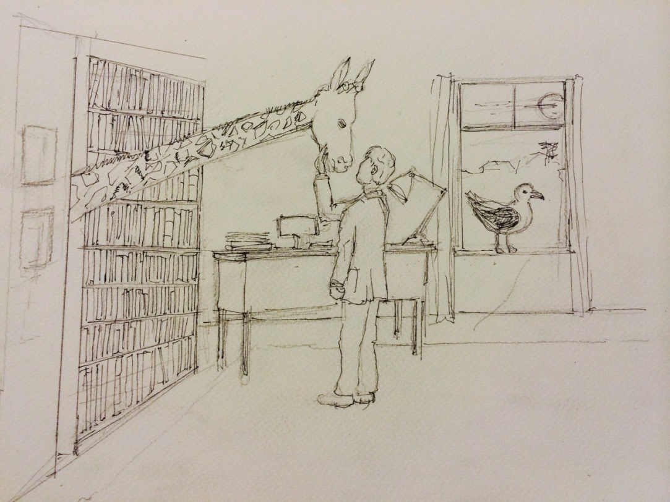
The first two acts are set in Bruce Mason’s office. The set has a conventional – box set quality. It is realistic with the detritus of a writer scattered about – there are bookshelves, a piano and a desk. Beyond there are windows and sky. The play is set towards the end of Brice Mason’s life – so the furnishings and wardrobe of the characters reflect this late 70’s, early 80’s tone. However as the work progresses the set starts to reveal it is not all it seems. The door keeps changing its location – at times all the furniture moves and tricks the unwitting characters trying to keep a grasp on what is true; when the piano is played it sounds like the typewriter and vice versa. We are also visited by a seagull from outside and more mysteriously a giraffe makes an appearance at times when characters are struggling with their sense of reality and consciousness.
At the beginning of the third act a transformation occurs in front of the audience’s eyes – the office of Bruce Mason dissolves and the expansiveness of Te Parenga beach arrives. All this is done by theatre illusion and trickery – there is no visible stage management – it is dreamlike and beautiful.

INNOVATION
Nightsong Productions and Theatre Stampede have always strived for innovation in their work. To this end they have undoubtedly succeeded. Their last collaboration ‘360 – a theatre of recollections’, was very innovative in terms of staging, script and creation. In the 2014 Auckland Theatre Awards it not only won an inaugural Excellence Award for ‘original concept and outstanding creative execution’ – it also won the people’s choice award and Hackman Cup for ‘Most Original Production’. Their previous work ‘Head’ resulted in the Chapman Tripp Award for ‘Most Original Production’. This work went on to be programmed at Ak07, where it had a sell-out season and was the only New Zealand work to be selected by The NZ Herald’s theatre reviewer as a highlight of that festival. One of the many factors that makes this collaboration stimulating is the push from all concerned to create original work - work that is not derivative; work that has not been seen before; work that excites the practitioners in regard to what is possible theatrically. All the works – including Te Pō and I’m Not A Still Life – offer a departure from the previous work and read as fresh and relevant propositions.

