Singapore Arts Festival Reviews
Performed at Victoria Theater, Singapore 21-23 August, 2014

TheBigStory

Theatre review: The Chorus; Oedipus is intimate in scale but epic in scope
Published on Aug 22, 2014 1:14 PM

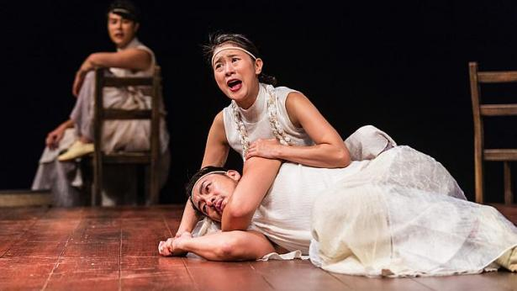
Scenes from The Chorus; Oedipus, a musical adaptation of the Greek tragedy Oedipus Rex by South Korean practitioners. Directed by Seo Jae-Hyung. -- PHOTO: TUCKYS PHOTOGRAPHY
- 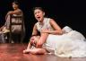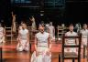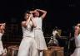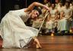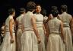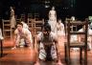

By Corrie Tan
Many modern interpretations of Greek tragedy tend to struggle with the distinction between the predictable and the inevitable.
The former drains a production of what essentially compels us to keep watching - a sense of fresh possibility - with a dull and painful trudge to the finish line; conversely, the latter prompts an increasing sense of dread and horror that tragedy is unavoidable, burrowing below the skin of what we already know will happen and sinking its teeth into the emotional fibre of our being.
The question remains: how do you retell something that has been told, over and over again, for nearly 2,500 years, without the curse of predictability hovering low overhead? The tale of Oedipus the King is one such tragedy, the bearer of a story so familiar that it is difficult to imagine how one might be able to raise it back to the heights it achieved in Ancient Greece as first penned by Sophocles in 429 B.C.
But this brutal and beautiful South Korean musical adaptation manages to do just that, dealing the play a literal sort of poetic justice with its emphasis on song and verse.
The story is the same. The young king Oedipus, intelligent and idealistic, has spent his life trying to escape an oracle's horrific warning: that he will kill his father and bed his mother. But in his desperation to avoid this fate, he propels himself straight into its arms.
Director Jae-Hyung Seo has homed in on the narrative device of the Greek chorus, elevating the group to share star billing with their protagonist. In lesser productions, the chorus can be an unwieldy, static appendage, but here it is a sinewy and muscled creature, every member moving as part of a collective whole with balletic rigour thanks to some sharp choreography by Eun-Jung Jang.
Together, the chameleonic chorus channels Oedipus' wracked soul, a murder of crows, an abandoned baby crying in the woods, a sinister wind rippling through the room, and everything in-between. They begin with a tightly-wound precision, but as Oedipus' inner world begins to unravel, so do the people around him; the chorus spins about the stage in a maelstrom of doubt and despair, and Oedipus is in the eye of the storm.
Seo places the audience right on the Victoria Theatre stage - so close you can smell the sweat of a dozen bodies moving in unison. He also reveals three pianists playing four pianos live, lending the play a tempestuous urgency with their rising and falling octaves and haunting chromatic scales in a magisterial score by composer Uzong Choe. This production, so rich in metaphor and imagery, also layers on a gorgeous choral landscape with the cast's layered harmonies, all beautifully sung.
Together, the audience members and the musicians encircle the main characters in the centre of the room, and Oedipus is confined to a circular wooden platform on the stage, unable to shake off the ticking clock of his own fate.
While we know both the cause and course of Oedipus' destiny, actor Hae Soo Park embodies his anguish and his disgust at himself so wholly that we are compelled to feel deeply for him. Is he a puppet of the gods for their cruel sport, or did his own actions, taken of his own volition, lead him to his doom? Despite my knowledge of the play, my heart ached as Oedipus shuddered at himself, retching as he evaluated the misdeeds his various body parts had committed, as if at odds with the very body that housed his soul.
It is the journey, rather than the visible end, that becomes the fulcrum of this production - Oedipus becomes extraordinarily sympathetic even as he seems to tempt the gods with his insatiable curiosity and his profound need to dredge up the terrible secrets of his past.
With all the guts and bloodshed of modern stage and screen, it is easy to be desensitised to the concept of violence, and how viscerally it affects a human being. This performance presents us a trembling Oedipus at his core, stripped of special effects, yet remarkably affecting - intimate in scale but so epic in scope.
corriet@sph.com.sg

Telling a well-known Greek tragedy to a predominantly English-speaking audience in Korean is no easy task, but Seoul-based theatre company Juk-Dal pulls it off with flying colours, as Gwen Pew discovers
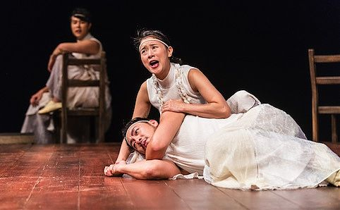
First published on 23 Aug 2014. Updated on 23 Aug 2014.
Telling a Greek tragedy to a predominantly English-speaking audience in Korean was never meant to be an easy task, but it was one that Seoul-based company Juk-Dal nonetheless took on bravely. And we’re happy to say that their meticulously planned gamble paid off.
Stripping everything back to basics, there is absolutely no untrimmed fat in their production of the 2,500-year-old tale. The story unfolds so simply and so elegantly, and yet even though we all know that King Oedipus was destined to kill his own father and have children with his own mother, the full weight of the tragedy is not lost on us during the climatic scene when he discovers the truth.
The set is minimalistic, but very clever. The edge of the stage is sealed off, and the audience is seated onstage along two perpendicular sides of the space. A slightly raised circular wooden platform sits in the middle with unlit globes of lightbulbs dangling sporadically above it and three upright pianos placed at one end, right next to a series of steps filled with wooden chairs that are largely occupied by the ensemble. Likewise, costumes are kept simple: everyone, regardless of whether they’re king or queen or peasant, is dressed in loose white robes. As a result of all this, we are encouraged to focus on the captivating expressions on the actors’ faces and their powerful voices instead.
The musical format also works surprisingly well and adds to the story by emphasising emotions of hope, frustration, fear or anger, while the positioning of the pianos – a fourth one, a grand, actually sits behind a door just offstage – gives surround sound a literal meaning. We can’t help but be drawn into the chaos that wrecks the great city of Thebes.
But of course, the best thing about the show is the cast. Under the brilliant direction of Jae-Hyung Seo, they are completely in their element. Hae Soo Park deserves special mention as the tormented Oedipus, and fully embodies the presence and spirit of the tragic hero; he is well supported by Kang Hee Yim and Kap Seon Lee as Queen Jocasta and his brother-in-law Creon respectively. The rest of the chorus are far from idle, too, and take their roles as seriously as their bodies physically allow them to.
By keeping things sharp and simple, the cast is able to achieve their most important goal: to tell a captivating story well. With that mission accomplished, everything else fell into place, and a beautiful piece of theatre worthy of the ten-minute standing ovation it received is born.
The Chorus; Oedipus is at the Victoria Theatre until 23 Aug.
By Gwen Pew

SIFA 2014: Oedipus gets the K-drama treatment
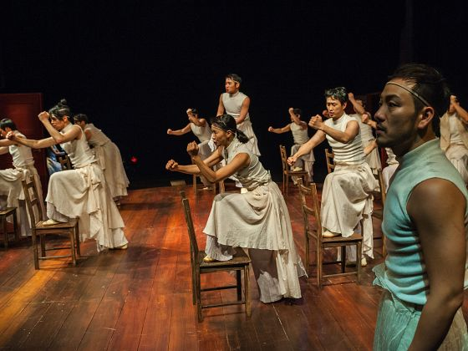
August 23
SINGAPORE — I’m really sorry, Nikhil Chopra, but your 50-hour performance will have to be demoted to second best SIFA show I’ve seen so far. At this point, it’s The Chorus; Oedipus who’s Rex. As in Rexellent.
Hey, we’re entitled to one horribly confusing pun per festival marathon right?
Every festival I’ve covered has offered at least one goosebump moment. I didn’t get any while watching his production — because it happened right at the very end. The entire thing was a goosebump moment.
Which wasn’t what I had expected. I mean, what’s the big deal about a Greek tragedy transformed into a Korean musical with a bunch of pianos, right? Well for starters, remember how we complained about how cramped Victoria Theatre looked in Facing Goya? In this one, you’re on the stage itself, surrounding the circular wooden platform on which the entire drama takes place.
Director Seo Yae-hyung has created one very powerful piece of theatre that simply won’t let go of you. The story of the ill-fated Oedipus and his equally ill-fated wife/mother Jocasta is well-known and yet, such is the gripping quality of its staging that you’re glued to it as if watching it for the first time, cringing and wincing as the two characters march to their tragic destinies. You feel the slow realisation of the horrors they find themselves in, the anguish and self-loathing bursting from the performances of the exceptional leads Park Hae-soo and Yim Kang-hee, as hubby/son and wife/mum, respectively.
Presented as a musical, huge credit, of course, goes to composer Choe Uzong and lyricist Han Areum. The near-hypnotic quality of the verses and the majestic music performed only on pianos is relentless. The energy and pace of the piece is such that there’s very little time to actually catch your breath. The proximity of the audience to the performers also ensured a very in-your-face, in-the-moment experience.
And then there’s the chorus.
Remember how The OPEN’s Medea On Media dragged that particular Greek tragedy to the present time? For all the contemporary “razzmatazz” (as the programme booklet says) it oozes (and assuming razzmatazz and tragedy is actually an okay mix), The Chorus; Oedipus is rather old school — the verses, maybe the costume, but most importantly, the huge presence of the chorus.
It reclaims its rightful space not only in the title (equal billing at that) but in the entire flow of the play itself — collectively, an ever-shifting creature that threatens menacingly or cowers in fear. I’m not sure about the “K-pop” namedropping in the publicity materials but the choreography, guided by Jang Eun-jung, sure is tight. The deft use of chairs, the atmospheric transformations into a chariot, a ship, a flock of birds — who needs a set when you’ve got a living, breathing all-purpose chorus?
The Chorus; Oedipus is sold out. But if you can get your hands on a ticket, you won’t regret it. The last show is tonight, 8pm, at Victoria Theatre. For more info on the festival, visit https://sifa.sg/

Breathtakingly stylish Oedipus - The Business Times
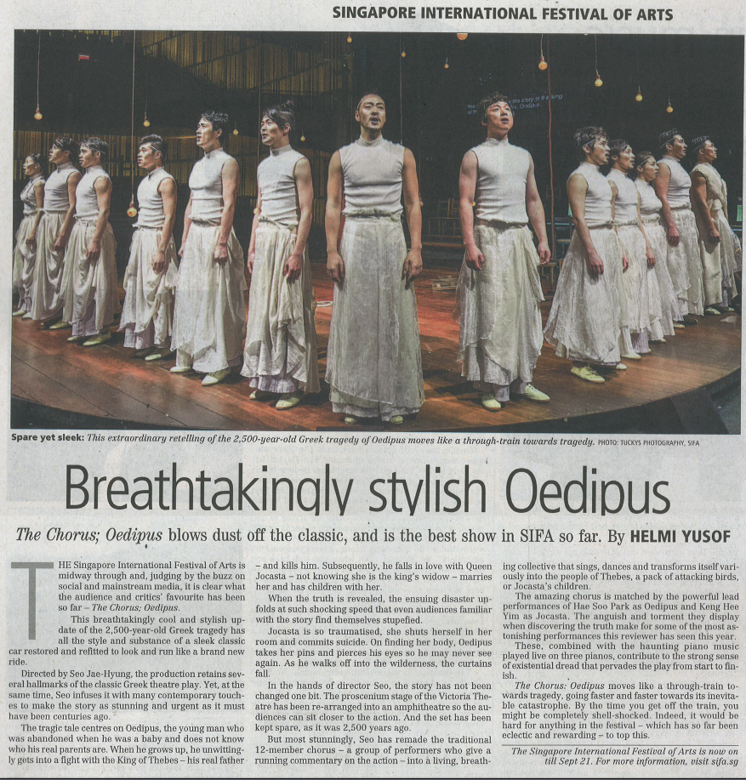
August 29, 2014

