Biographies - Duck Death and the Tulip
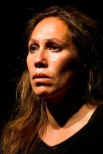
Nina Nawalowalo – Director
Nina Nawalowalo started her career as a sports woman representing New Zealand in Basketball then training at Wellington Teachers College stimulated a passion for theatre. After qualifying as a teacher she travelled to London to study Mime with Desmond Jones. From London she went on to study under the world famous Phillipe Gaulier, Paris. For six years she performed and taught all over the world with Richard MacDougall, world champion close up Magician. Together they created new works from a unique blend of magic, mask and clown collaborating with many greats including Pierre Byland and members of Theatre de Complicite.
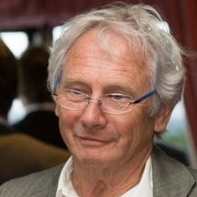
In 1994 Nina was awarded the prestigious comedy award from the International Brotherhood of Magicians. Her work has been selected for and performed at many international festivals including: London International Mime Festival, British Festival of Visual Theatre, Ulster Comedy Festival, Moscow Arts Festival USSR, The Magic Castle Los Angeles and the London International Workshop Festival. On returning to New Zealand she became a familiar face on the hit children’s television programme Where in the World is Carmen Santiago?
Directing work followed with a string of critically acclaimed shows in the Wellington theatre scene. Nina is also a regular tutor at Toi Whakaari, The New Zealand Drama School.
Peter Wilson – Writer (of stage play), Performer
Peter is the Founder and Artistic Director of Little Dog Barking Theatre Company. He trained as a classical dancer but after seeing visiting English Mime and Puppet Artist, Cilli Wang, he became fascinated with the possibilities of these art forms. Determined to know more, study took him to the Puk Theatre of Tokyo, The Bunraku Theatre, National Theatre of Japan, The Central Puppet Theatres of Prague and Moscow and the Cannon Hill Puppet Theatrein the UK.
Returning to Australia in 1973 he founded the Tasmanian Puppet Theatre and after ten years at the helm as Artistic Director was appointed Artist in Residence at Curtin University in Western Australia. This was followed by the critically acclaimed production of Doctor Fautus for the 1981 Festival of Perth. Staying on in Perth, Western Australian he established the Spare Parts Theatre and within a short period of time the Company was touring nationally across Australia and internationally to Japan, China, Korea, USA, Canada and Singapore. He has collaborated to create new work with artists from around Australia and internationally from Japan, China, USA and the Czech Republic.
In 1997 he moved to New Zealand where he was appointed Artistic Director of Capital E National Theatre for Children, he remained with the company for 13 years. His commitment to high quality work for children is a testament now to that company’s reputation.
Peter has created work as a freelance Director / Devisor for the Shanghai Puppet Theatre, Drak Theatre in the Czech Republic, Handspan Theatre, Java Dance Company, Sydney Metropolitan Opera Company, Footnote Dance and the Marionette Theatre of Australia.

Gareth Farr – Composer
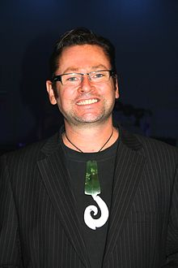
Gareth is one of New Zealand’s best known composers. He studied composition and percussion in New Zealand and New York, where he graduated Master of Music. Since 1990 his works have been commissioned and performed by the NZSO, the Auckland Philharmonia, the New Zealand String Quartet, and a variety of other professional musicians in New Zealand and overseas. He has been commissioned to write music for many high-profile events including the 50th anniversary of the New Zealand Symphony Orchestra, the opening of Te Papa, and the Olympic Games in Sydney 2000, and Beijing 2008. In 2006 Gareth was made an Officer of the New Zealand Order of Merit and was the recipient of an Arts Foundation Laureate award in 2010. He has composed music for over 30 theatre productions in New Zealand, and has been awarded three Chapman Tripp Theatre Awards for Outstanding Composer of Original Music.
Recently, Gareth was commissioned to write music for the 2011 Rugby World Cup opening ceremony and games.

Kenny King –Performer
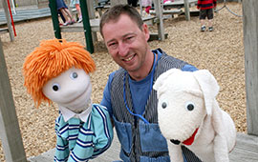
Kenny King trained at Toi Whakaari, the New Zealand Drama School, since graduating he played a variety of roles for various theatre companies including a long time member of The Improvisors. He has a special interest in puppetry and has performed for Capital E National Theatre for Children in Farm at the End of The Road, Kiwi Moon, Paper Shaper and won a special Chapman Tripp Theatre Award for his puppetry and manipulation in Endgame in 2010. Kenny has been a member of Little Dog Barking Theatre since its inception, playing the major solo role in Piggies and A Sausage Went for a Walk, Pond and Rupert. He created the role of Guji Guji in the theatre’s production of the same name and has played Duck, in the theatre’s production of Duck Death and the Tulip on its recent United Kingdom and China tour. Little Dog Barking’s production of Paper Shaper, with Kenny playing the title role ,won Best Foreign Drama Award at the recent Asian Pacific Puppet Festival in China.

Performers
Kenneth King
Peter Wilson
Creative Team
Director – Nina Nawalowalo
Writer (of the stage adaptation) – Peter Wilson
Composer – Gareth Farr
Designer – Nicole Cosgrove
Puppet Designer – Sue Hill
Lighting Designer – Nigel Percy

