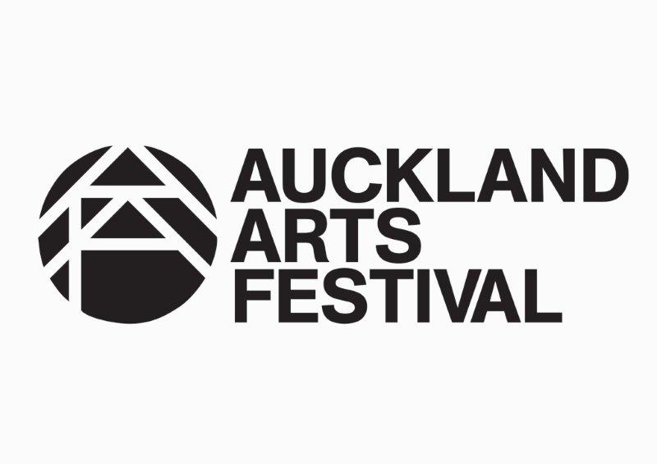
PRIVACY POLICY (2013)
- Your contact information is collected and held by the Auckland Arts Festival Trust (AAF) and in case of a ticket purchase with the appointed ticketing agency. The information is used to contact you, when necessary, with regards to AAF News and offers.
- The AAF will not sell, trade or rent your contact information to others without obtaining your consent, unless required to do so by law.
- You are entitled to have access and/or request corrections to your information.
- If you do not wish to receive mail or email from the AAF in the future, please send an email to info@aaf.co.nz or call us on 09 309 0101.
- If you are photographed, filmed or taped whilst attending an AAF performance, you consent to AAF or third parties appointed by the AAF photographing, filming and taping you. AAF or third parties appointed by AAF can broadcast, publish, license and use any photographs, film, recordings and images of you without compensation. AAF, the third parties and anyone acquiring from them a right to use the material are not liable to you in any way for its use.
- We will only use personal information that you provide to us to send you your tickets, information regarding concerts, other news and information about the AAF, and occasional offers from our sponsors and funding partners. We will not share your personal information with any other organisations without your express permission.
INTERNAL USE ONLY:
The AAF’s privacy officer is the Marketing and Development Director, Arne Herrmann

